# Story 9. Show list with FREE or reserved spots

As a registered user  
I want to get a list of all the free or all the reserved spots  
so that I can see all the free or reserved spots in a list.

## Acceptance criteria:

* A list with all the free spots is shown when I push the free spots button.
* A list with all the reserved spots is shown when I push the rederved spots button.

## Wireframes:

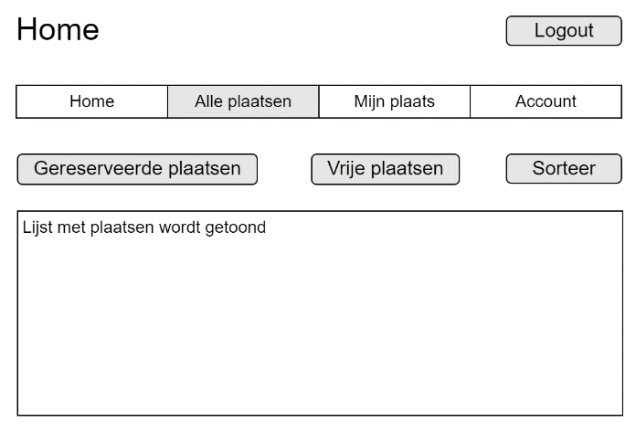

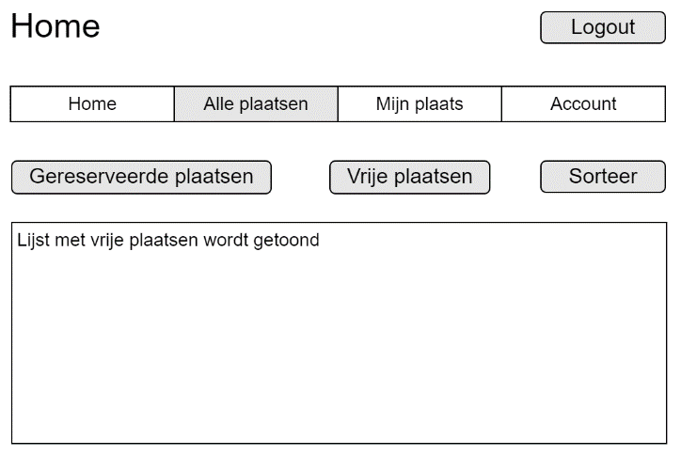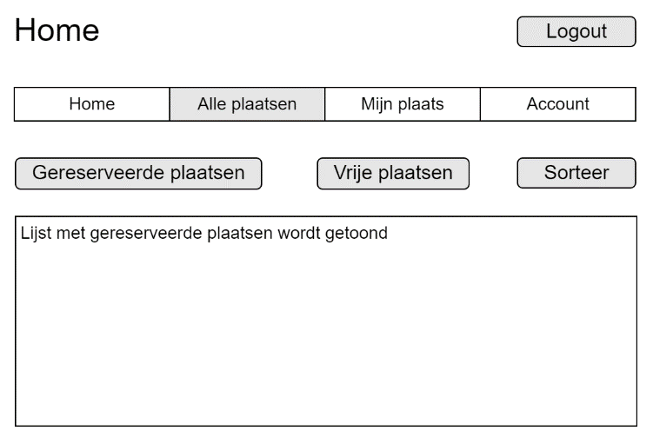

Reserved spots

Free spots